**Synopsis of**

**Online Grocery Shopping System**

**ONLINE GROCERY SHOPPING SYSTEM**

**INTRODUCTION**

Online Grocery Shopping is the norm these day. There are lot of successful websites such as BigBasket.com, askmegorocery.com etc in this space. Purpose of Online Grocery Shopping system is to allow customer to shop will increase the ease, efficiency and reduce the chance of manual errors. With the popularity of PCs, and mobile easy access to internet and World Wide Web (WWW), Internet is increasingly used by consumers & vendors as a channel for shopping, payment & other operations.

**OBJECTIVE**

The main objective of proposed system, is used to provide Online Grocery Shopping solution to consumers and vendors. It will automate some of the basic operations of an online store. Scope would be to provide basic functionalities using a web application so that those manual process can be automated. It will include to provide administration access to vendors and admins and use specific access to customers.

**BACKGROUND**

In fast pace of time today everyone is squeezed for time, people want to easily shopping without going to shope. The software has ability to host allow a user to maintain the online shopping system. In the on-line grocery shop to provide many facilities like home delivery at the time, debit card/credit card/net banking/cash on delivery payments systems, add cart or remove etc.

**HARDWARE AND SOFTWARE REQUIREMENTS**

We can operate the software online shopping system is electors consist of plug and jacks. The system must run the internet, all the hardware shall require to connect interface for the system.

The Software Requirement Specification is produced at the culmination of the anaslysis task. The function and performance allocated to software as part of system engineering are refined by establishing a complete information description, a detailed function and behavioral description, an indication of performance requirements and design constraints, appropriate validation, criteria, and other data pertinent to requirements.

**Following software is used:**

* Any windows operating system
* Text editor such notepad++
* MySQL database
* Software written in PHP, HTML, CSS and JavaScript Language

**ERD and DFD**

**>> DFD (Data Flow Diagram):**

The Graphical representation of data flow direction in any system is called data flow diagram. It describe the process through which data comes as input and stores in server for future use. DFD can derive into physical and logical, the logical data flow describes through system to perform certain functionalities of the system but the physical data flow diagram describes the implementation of logical data flow.

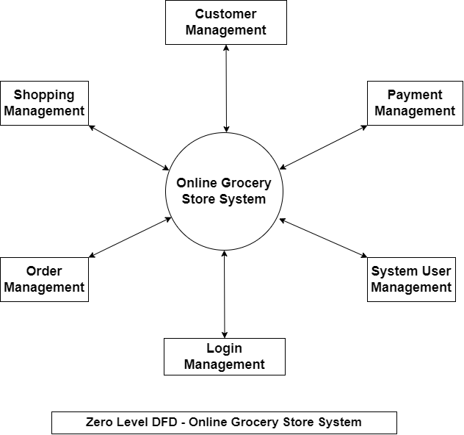

**Diag-1; Data Flow Diagram (Level-1)**

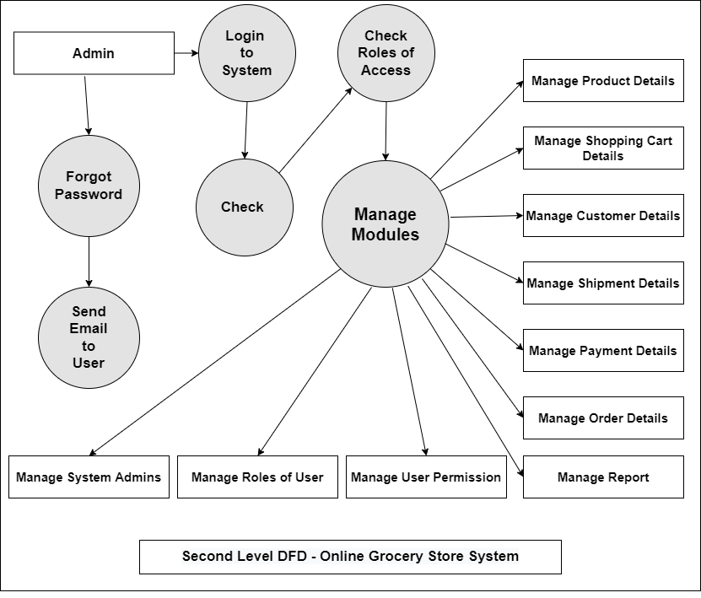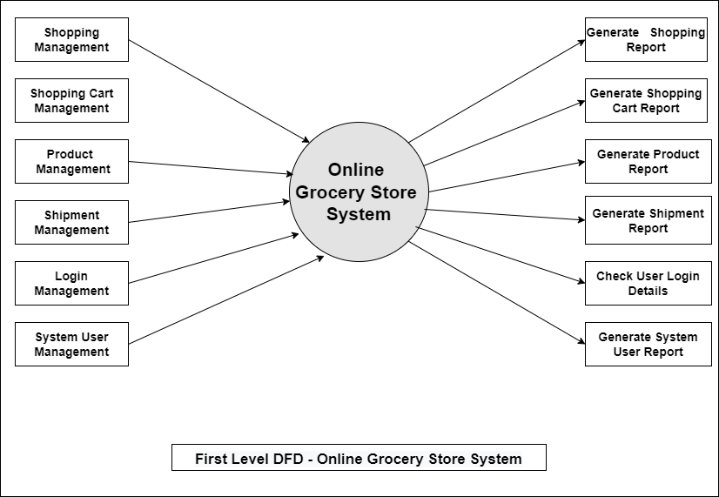

**Diag-1; Data Flow Diagram (Level-2)**

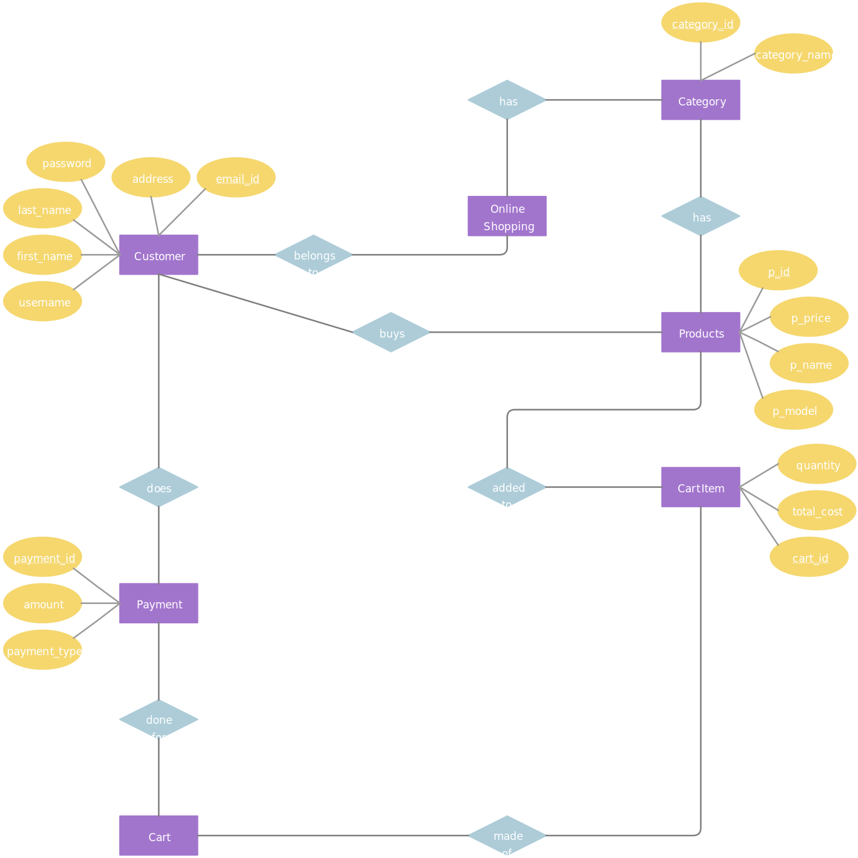**>> ERD (Entity Relationship Diagram):**

**Database Schema**

**MySQL Server**

My Admin may be a free software tool written in PHP intended to handle the administration of MY SQL over the planet Wide Web. MY SQL support a wide range of operation. Most frequently used operation are support by the interface while you continue to have the power to directly execute any SQL statement.

**Future Scope**

* There will be lot of scope to improve this project, since currently basic functionality would be provided.
* Some of the modules to improve are admin part such as personalized recommendations, discount & offer management. For customers, notification & messaging etc can be improved. These can be developed to make it more effective.

**CONCLUSION**

Our project is only a humble venture to satisfy the needs to manage their project work. Several user friendly coding have also adopted. This package shall prove to be a powerful package in satisfying all the requirements of the school. The objective of software planning is to provide a frame work that enables the manger to make reasonable estimates made within a limited time frame at the beginning of the software project and should be updated regularly as the project progresses.

**REFERENCES AND BIBLIOGRAPHY**

* <https://www.w3schools.com/php/>
* <https://www.w3schools.com/html/>
* <https://www.youtube.com/watch?v=v1otHJGlV5g&list=PLEiPMJpUdbj6a2p9Pt6tBdJhcqmWgX7Oa>
* <https://www.youtube.com/watch?v=-ghFCt5TA2I&list=PLEiPMJpUdbj7t8YCcKvame-RBlNIQeh01>